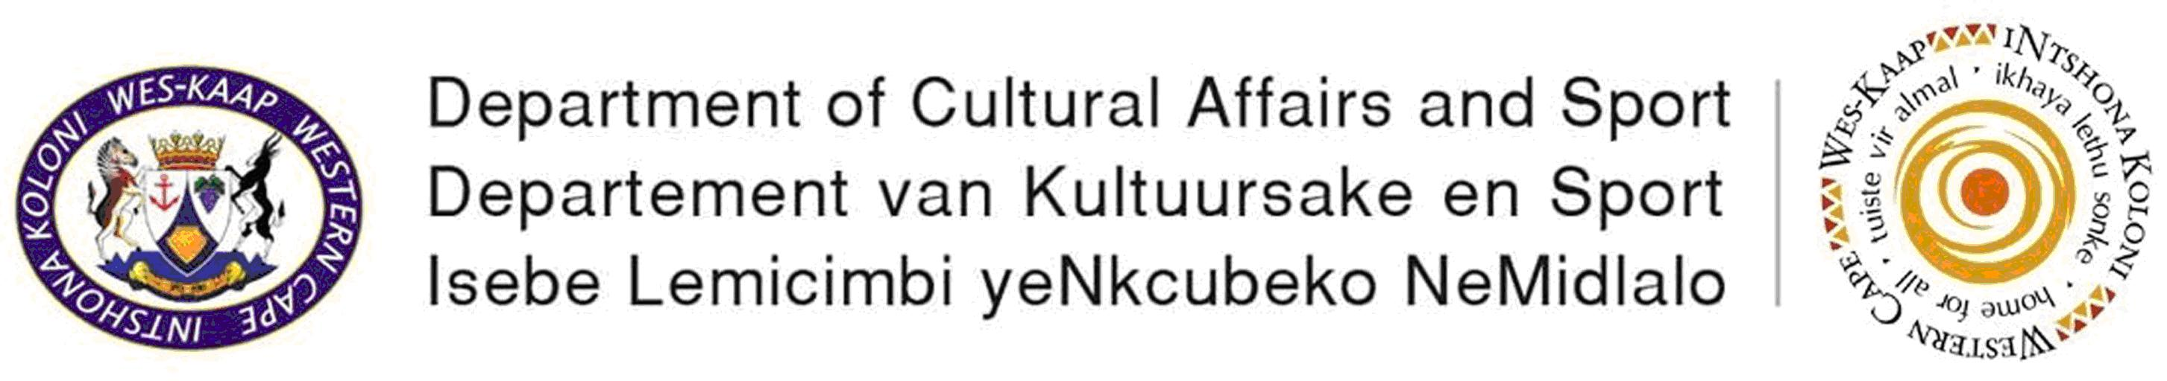

NEWSLETTER

Introduction

End of another successful but challenging year for the Interim Western Cape Musicians Association

We wish to inform you of our achievements to date. This could not have been achieved without your support.

Achievements of the Interim Western Cape Musicians Association:
- Finalised a draft constitution
- Registered as a Section 21 company, in the name of Western Cape Musicians Association
- Opened a banking account, in the name of Western Cape Musicians Association
- Elected an interim chairperson, secretary and treasurer
- Organised the music programme at the Provincial Xhosa Festival, which was managed by the language unit of the Department of Cultural Affairs & Sport. It created income for about 40 -50 musicians, mostly from the Langa community.
- The Western Cape Musicians Association identified the need for education for the music practitioners in the music business. In collaboration with the National Department of Arts & Culture, the Department of Cultural Affairs & Sport, hosted workshops in Langa and Kayamandi.The workshops were funded by the National Department of Arts & Culture, and presented by Moshito.
- In collaboration with the Department of Cultural Affairs & Sport, hosted cultural events in Kayamandi and Bridgton, Oudtshoorn.The rich and diverse talent of the local musicians were showcased. Through these events, job opportunities were created for musicians from these communities.
- The structure called on the Department of Cultural Affairs & Sport to assist the youth brass bands with the relevant training, to enhance their professionalism as well as their standard. Professional musicians are currently training the Sensational Youth Development Brass Band, situated in Lavender Hill. This initiative is a Pilot project, for future training for Youth brass bands in other communities.
- Certain members of the Interim Western Cape Musicians Association accompanied the Minister of Department Cultural Affairs & Sport: Recreation on his road show in all the regions. He engaged with the relevant persons in all the regions, listening to their challenges experienced in the music industry.

- The benefits of the road show to the structure were as follows:
  - Raised awareness of the Interim Western Cape Musicians Association across the Western Cape
  - More persons registered onto the database
  - Listening and seeing all the challenges (e.g. lack of venues for rehearsals, meetings or events, lack of relevant structures, lack of recording studios etc.)
  - Also becoming more aware of the lack of resources for music practitioners in the rural areas.

FUTURE PLANS
- The Interim Western Cape Musicians Association is currently busy organizing the Provincial Musicians Conference 2007.The preliminary date is Saturday, 10 February 2007.Further information will be disseminated in due course.
- Through the established partnership with the Department of Economic Development and Tourism, undertake initiatives that will contribute to the economic growth of the music industry.
- Create job opportunities for the music practitioners of the Western Cape through the established partnership with Department Cultural Affairs & Sport.
- Lobbying for funds from government departments as well as from private organisations / structures
- Give assistance to the music practitioners from the Cape Wine-lands, West Coast and the broader Overberg region, to establish the regional musicians structures
- Addressing the crucial issues like benefits for the music practitioners; thus engaging with the relevant role-players
- Organizing seminars etc. for the music practitioners of the different music genres e.g. reggae, hip-hop etc.
- Distribution of regular newsletters to the registered members
- Organise more awareness campaigns to individuals from the music industry, increasing the members onto the database

DRAFT CONSTITUTION
NOTIFICATION OF AVAILABILITY OF DRAFT CONSTITUTION

The Department of Cultural Affairs and Sport in conjunction with the Interim Western Cape Musicians Association is currently busy to structure the music industry. A draft constitution is available for review and comment from persons in the music industry.

Copies of the draft constitution (in the 3 official languages) will be available at the following venues, from Wednesday, 8 November 2006.

1. Head Office: Department Cultural Affairs and Sport
Protea Assurance Building,
3rd floor, Cape Town, 8000
Ph: 021- 483 9722

2. Regional office: Department Cultural Affairs Sport
31 Matzikama Street,
Vredendal, 8160
Ph: 027 213 3018

3. Regional Office: Department Cultural Affairs Sport
Seppie Greeff Building
2nd Floor, Voortrekker Road,
Oudtshoorn, 6625
Ph: 044 279 1766

4. Cape Gateway Website
http://www.capegateway.gov.za/culture sport

Please, submit comments on the draft constitution, not later than Friday, 12 January 2007, using the contact details provided below:

Department Cultural Affairs & Sport
Attention: Lindsay Jeptha
Private Bag X9067
Cape Town, 8000
Fax: 021-483 9711 or email: ljeptha@pgwc.gov.za

EXCITING NEWS
The music practitioners from the rural regions established three regional structures. They were pro-active, calling meetings in their different communities, had elections and organized themselves into formal structures.

The Interim Western Cape Musicians Association salutes you for taking your initiative forward, collectively in the future (election at conference 2007) the Western Cape Musicians Association will be able to take the music industry to a more structured and professional level. Enabling the structure to address the needs and challenges of all music practitioners - regardless of race, demographics, economic status etc.

THE ESTABLISHED REGIONAL STRUCTURES ARE AS FOLLOWS:
  - Overstrand (part of Overberg region) – John Matthews
  - Beaufort West (part of Central Karoo) – Samuel Jacobs at Ph 023- 414 4933
  - Eden – David Lucas at Ph 083 875 3762

Let’s Make Music

The Interim Western Cape Musicians Association in collaboration with the Department of Cultural Affairs & Sport wishes you a blessed festival season.

