Spatial Development and Infrastructure Planning Support Strategy
Municipal Support
11 March 2016

- SETTING THE SCENE
The Provincial Strategic Plan: 2014-2019 (16 September 2015) sets out the Western Cape Government’s vision and strategic priorities. The PSP includes five (5) Strategic Goals, each backed by a plan to maintain continuous improvement in the lives of citizens. These Provincial Strategic Goals (PSGs) are included in the table below.
The Provincial Strategic Goals
- Create opportunities for growth and jobs
We are committed to creating an enabling environment to attract investment, grow the economy and create jobs by supporting high growth economic sectors.
- Improve education outcomes and opportunities for youth development
We’re committed to expanding quality education across the province and providing opportunities for youth to realise their full potential.
- Increase wellness and safety, and tackle social ills
We’re committed to addressing health, safety and social ills by supporting healthy communities, a healthy workforce, and healthy families, youth and children.
- Enable a resilient, sustainable, quality and inclusive living environment
We’re committed to improving urban and rural areas through enhanced management of land, an enhanced climate change plan, and better living conditions for all.
- Embed good governance and integrated service delivery through partnerships and spatial alignment
We’re committed to delivering good governance and an inclusive society that increases access to information, in partnership with active citizens, business and institutions.

The graphic below unpacks PSG 4: Enabling a Resilient, Sustainable, Quality and Inclusive Living Environment. The graphic indicates four (4) Work Groups (in green) and four (4) Sub-Work Groups (in pink). This report is a deliverable of the Spatial Development and Infrastructure Planning Support Sub-Work Group.
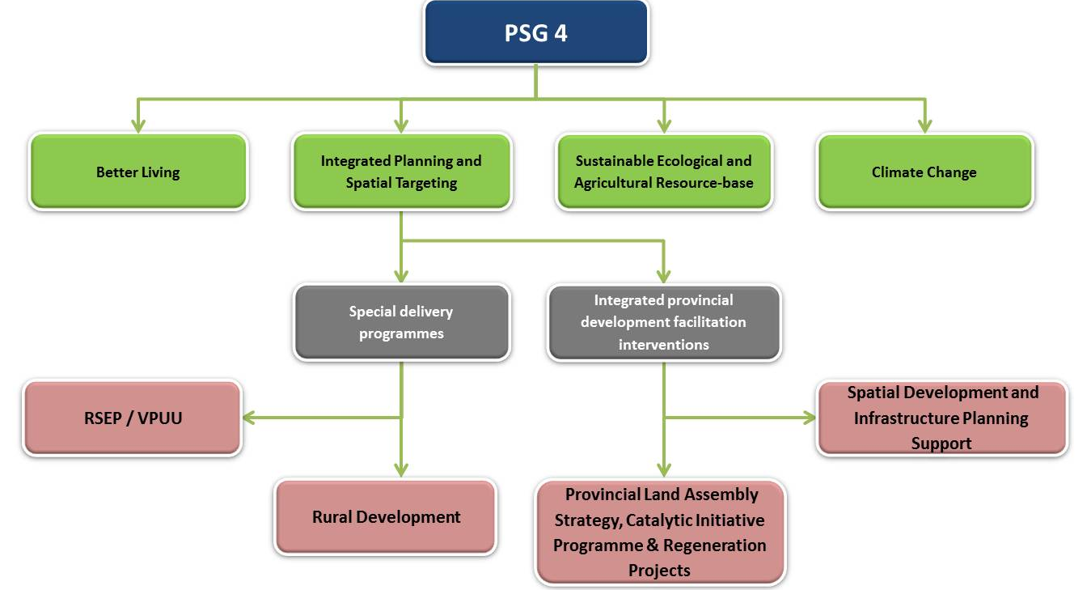
- SUB-WORK GROUP: PURPOSE
The Sub-Work Group aims to improve the resilience, sustainability, quality and inclusivity of urban and rural settlement through the improved integration of and improved implementation of Municipal Spatial Development Frameworks, Integrated Transport Plans, Integrated Human Settlement Plans, Integrated Waste Management Plans (including Waste Infrastructure Planning) and Infrastructure and Growth Plans. The aim is to improve the planning process, the substantive content and the implementation of these plans.
- SUB-WORK GROUP: DELIVERABLES
The Sub-Work Group’s Project Initiation Document (PID) lists four (4) deliverables (refer to the table below). This report refers to Deliverable 3: Support to the Western Cape Municipalities with the integration of their Integrated Human Settlement Plans, Infrastructure and Growth Plans, Waste Infrastructure Planning, and Integrated Transport Plans into Municipal Spatial Development Frameworks, and to improve the substantive content of all of these plans.

Deliverable 1:
Develop a new Standard Operating Procedure (SOP) for the integration of Integrated Human Settlement Plans, Infrastructure and Growth Plans, Waste Infrastructure Planning, and Integrated Transport Plans into Municipal Spatial Development Frameworks.

Deliverable 2:
Develop a guideline on improving the integration and substantive content of Integrated Human Settlement Plans, Infrastructure and Growth Plans, Waste Infrastructure Planning, and Integrated Transport Plans, and Municipal Spatial Development Frameworks.

Deliverable 3:
Support to the Western Cape Municipalities with the integration of their Integrated Human Settlement Plans, Infrastructure and Growth Plans, Waste Infrastructure Planning, and Integrated Transport Plans into Municipal Spatial Development Frameworks, and to improve the substantive content of all of these plans.

Deliverable 4:
Reviewing the Spatial Development and Infrastructure Support Strategy annually.

- PREVIOUS DELIVERABLES
This report builds on the outcomes of Deliverable 1 (Develop a new Standard Operating Procedure (SOP) for the integration of Integrated Human Settlement Plans, Infrastructure and Growth Plans, Waste Infrastructure Planning, and Integrated Transport Plans into Municipal Spatial Development Frameworks) and Deliverable 2 (Develop a guideline on improving the integration and substantive content of Integrated Human Settlement Plans, Infrastructure and Growth Plans, Waste Infrastructure Planning, and Integrated Transport Plans, and Municipal Spatial Development Frameworks.

The approach adopted in Deliverable 1 included the creation of an IGR platform where representatives responsible for and/or involved in the drafting and/or amending the 5 sector plans listed above come together and discuss any area of conflict, duplication and/or opportunities for synergy. The IGR platform, which was termed the Intergovernmental Planning Committee (IPC), has two key but interlinking functions.
The first would be to ensure that the relevant officials in each sector are aware of and party to any proposed changes to the 5 sector plans mentioned above. Through this awareness of and participation in the changing sector plans any area of conflict, duplication, and/or opportunities for synergy with the other sector plans can be easily identified.
The second role is to build on the areas of opportunity, remove areas of duplication, and resolve areas of conflict. This will occur through focused discussion which includes all relevant officials with a keen understanding of the geographical area in question. The outcome of these discussions will be the adoption of an agreed-to way forward which has been arrived at through negotiation and compromise.
Deliverable 2 consisted of a Guideline which aimed to ensure the successful implementation of the adopted approach. The Guideline unpacked the roles and responsibilities of the IPC members as well as any sub-committee that may be established. It also provided the basis for a generic Terms of Reference for the IPC, and any potential sub-committee, which elaborates on the functions and composition.
- MUNICIPAL SUPPORT
Due to the strategic role the Integrated Development Plan, and more particularly the IDP Managers’, play in municipal planning and budgets the IDP Managers’ were identified at an early stage as core members of the IPC. It was therefore logical that the Sub-Work Group concluded that the best forum through which the adopted approach should be workshopped would be the IDP Managers’ Forum.
As such, the Spatial Development and Infrastructure Planning Support Strategy was placed on the agenda of the IDP Managers’ Forum meeting on 4 March 2016 however the presentation was removed from the agenda on the morning of the session. The Forum’s Chair concluded that the subject matter should first be workshopped with Provincial Strategic Goal 5: Embed good governance and integrated service delivery through partnerships and spatial alignment.
Despite not being permitted to present at the IDP Managers’ Forum the IDP Managers were introduced to the new legislation governing spatial and land use planning at all three spheres of government. The new legislation emphasises the importance of spatial planning and the need to like spatial planning with the Municipal Systems Act (Act 32 of 2000), the Act which governs IDP.
The presentation on the new planning legislation was to be used as an introduction into the presentation on the Spatial Development and Infrastructure Planning Support Strategy discussion for the following reasons.
Firstly, the concept behind the Intergovernmental Planning Committee presented in the SOP originates from the new planning legislation at the provincial level, the Western Cape Land Use Planning Act (Act 3 of 2014)(LUPA). This is discussed further in Deliverable 1: the Standard Operating Procedure.
Secondly, the new Municipal Systems Act is noted in Deliverable 1: Standard Operating Procedure, as one of the pieces legislation that promotes integration and alignment of plans across the various spheres of government. This is achieved through the Municipal IDP. The Municipal IDP is also the mechanism through which budget is associated to projects. As such, if the Spatial Development and Infrastructure Planning Support Strategy improves the integration and alignment of the 5 sector plans and this integration and alignment extends to the Municipal IDP then it is a logical conclusion that the associated budget of all three spheres of government will follow.
While the presentation on the new planning legislation was not used as an introduction to the presentation Spatial Development and Infrastructure Planning Support Strategy it did start an interesting discussion which has relevance here. Some of the discussion points have been included below.
- There is common agreement that spatial planning is embedded in the legislation and particularly in the Municipal Systems Act (Act 32 of 2000).
- Spatial planning must occur through the IDP process as prescribed in the MSA.
- Improving communication between the planning, housing, transport, solid waste, and infrastructure officials and the IDP Manager would assist in improving the quality of municipal IDPs as it may lead to projects identified by the planning officials being included in the IDP budgets and plans from an early stage.

- WAY FORWARD
Based on the interlinkages and similarities of the Sub-Work Group and PSG 5, and in an attempt not to lose the work done thus far, it is proposed that the Sub-Work Group be absorbed into and developed further under PSG 5.
It is further proposed that the Planning Heads Forum, which includes the Chief Town Planners of all Western Cape Municipalities, and the IDP Managers’ Forum should hold a combined session in the near future. This session will not replace the individual forums but rather assist in developing the SOP and Guideline further in the interest of both sectors. The combined session may decide to continue to meet in a combined fashion but that is up to the quorum to decide.

