

**APPRENTICESHIP GAME CHANGER**



Guideline

Technical Advisory Forums (TAFs)

16 August 2017

1. **Background: The Apprenticeship Game Changer**

*It has become increasingly evident that we need a new way of delivery, one that is uncompromisingly results-focused and performance-driven*.

Premier Zille, November 2014

The Western Cape Provincial Cabinet entered its second term of office (2014-19) with a commitment to deliver faster results and increased citizen satisfaction with government services. To achieve this, it selected a few key strategic priorities that would be subjected to a new delivery approach. These priorities, or Game Changers as they are commonly referred to, needed to set a high benchmark of impact and delivery. To achieve this, an extensive design process brought together government officials, civil society, private sector and experts, out of which emerged seven Game Changers, one of which is the **Apprenticeship Game Changer.**

Too many young people walk the streets, armed with a matric certificate or a college qualification, unable to get work. Too many businesses complain that they cannot get the requisite skilled work ready labour to support expansion and new investment. And, too long we have been caught in this quagmire. The Apprenticeship Game Changer is focused on getting us out of it. To do so, this game changer is focused on aligning supply where the demand is greatest and improving the work readiness of learners, notably in those sectors that are of strategic significance in the Western Cape. The growth sectors as identified through Project Khulisa during 2015 are for the immediate future are:

* Oil and Gas (including Rig Repair)
* Agri-processing; and
* Tourism.

In addition, there are two critical enabling sectors that need attention to allow for the growth of the Project Khulisa sectors, being:

* Energy and Water
* Information Communication Technology (including Broadband).

Key to this highly focused **occupation per sector** approach is “data”. There is a need to know which occupations are required within each priority growth sector? How many of each occupation? How many skilled people are available for each occupation? How many do we need to train? How many people are in training already for these occupations? These questions and others that may arise, allow for a scientific decision making process to occur, which is highly dependent on accurate, live, disaggregated real time data based on the needs of employers in all the above sectors. However, employers need to be fully integrated into this process or the Apprenticeship Game Changer will not succeed. This guideline explains the process that will be implemented to bring employers on board to become the drivers for the Apprenticeship Game Changer through Technical Advisory Forums (TAFs).

1. **Role of the Employer within the Skills Game Changer.**

There are three distinct but related “pools” of persons that make up the Apprenticeship Game Changer. A linear relationship allows the progressive movement of persons from academic supply (e.g. School or College) to workplace supply (e.g. Apprenticeship) to actual employment in the priority economic sectors. However, the linear movement is not a programmed process – i.e. a specific person is NOT targeted all the way through the system. Each “pool” is grown by Stakeholders for different reasons.

These three distinct but interrelated pools of Stakeholders enable a “push strategy” for learning institutions to supply learners with appropriate skills and competencies to the priority economic growth sectors as well as a “pull strategy” to ensure that the priority economic growth sectors clearly signal their specific human resources needs in terms of appropriate skills and competencies. Globally it is evident that the more employers participate and are involved in three stakeholder pools of the push – pull strategy, the better the skills system in a country.

This push / pull approach is illustrated in the infographic below.

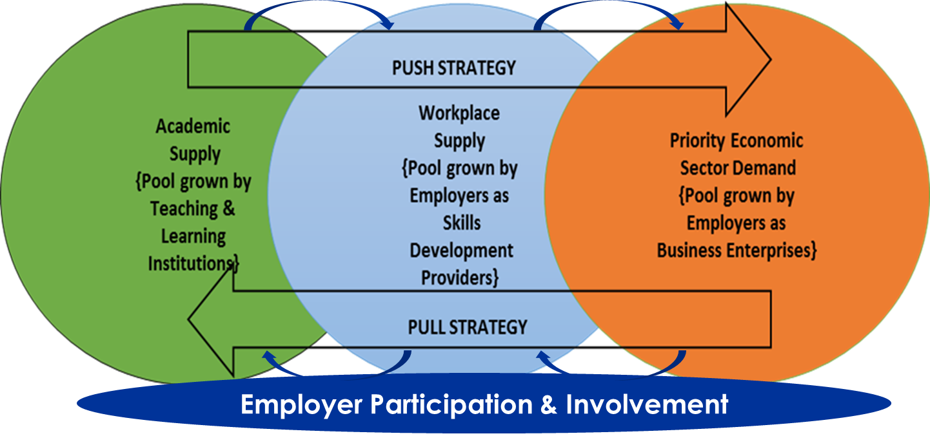

Figure 1: "Push and Pull" Apprenticeship Game Changer Strategy

Although all three pools of stakeholders are required for the successful implementation of the Apprenticeship Game Changer, the most critical common denominator that acts as a bridge between the world of learning (academic supply) at an institution and the world of learning at work (workplace supply) is the employer. The employer creates the environment wherein learners can practice their skills that eventually lead them to become competent workers in their chosen occupational fields.

However, the employer bridge is a not a naturally occurring phenomenon but is a mechanism that is created, developed and nurtured through consistent and sustained partnerships and coordination between specific groups of stakeholders that is underpinned by sharing critical DATA between partners, as is illustrated in the Apprenticeship Game Changer infographic below.

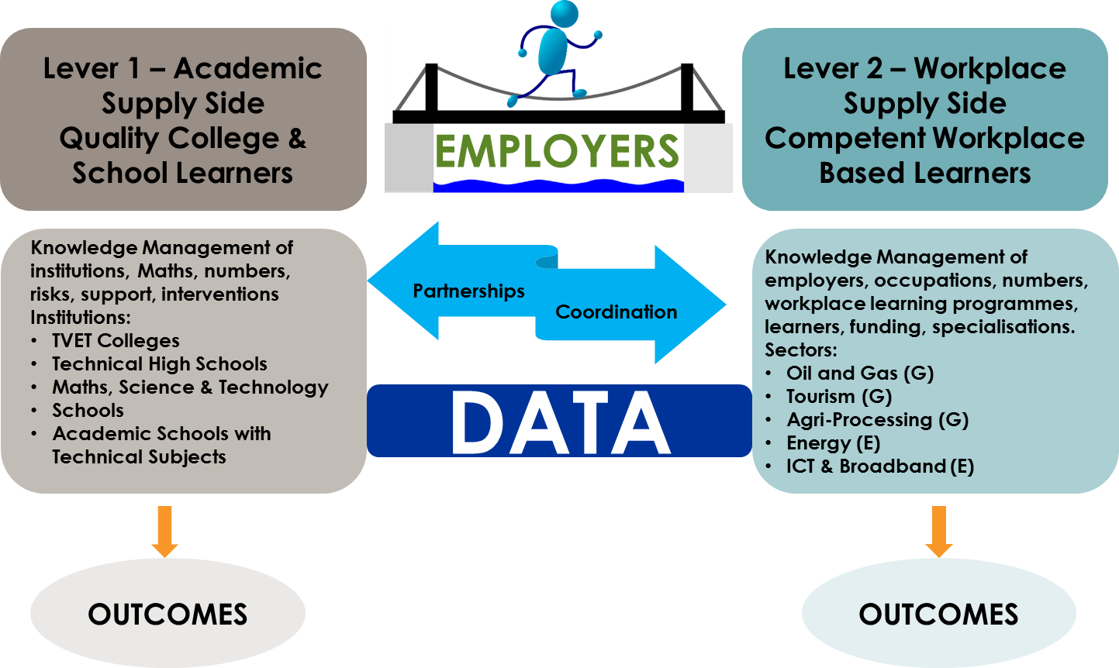

**Figure 2: The role of the Employer as a "BRIDGE” in Apprenticeship Game Changer**

Globally the most well-known bridging mechanism between the world of learning at an institution and the world of learning at work is the apprenticeship system that has seen a huge resurgence across the globe in the last decade. This not a surprise since apprenticeship training, especially if delivered at a world class standard, can raise the number of people in employment, increase individual and company productivity and enhance economic growth[1]. Apprenticeship training resonates very clearly with the Goal of the Apprenticeship Game Changer, **“To achieve sufficient, appropriately qualified technical & vocational skilled people to meet the needs of prioritised economic growth areas in the Western Cape”.**

Employers in the context of the Apprenticeship Game Changer are defined at its broadest level as any workplace environment that allows a person, known as a learner, to progressively over a period of time acquire knowledge and skills through applied practise to become a competent and productive worker in his or her chosen preferred occupation. This broad definition of a workplace is given a specific focus within the Apprenticeship Game Changer to align to the occupations required by the five economic sectors noted under section 1, but is stressed that the workplace learning environment may not necessarily be within those economic sectors specifically. As an example, electricians are required, but an electrician could be developed within a mining sector and then find work in the Agri-processing sector. Competence is occupation based with sector competence being acquired through day to day work practises.

This approach to workplaces therefore allows the inclusion of not only the private sector but also government at all levels, state owned companies, NGOs etc. the only base requisite is an environment that allows quality learning to take place. The tools, equipment, infrastructure that is required for the quality learning environment differs from occupation to occupation such as that required by an electrician compared to a chef, but the one common denominator across all workplace based learning environments is presence of an “expert” or “master” often known as a mentor or coach, historically also known as a journeyman within traditional apprenticeship systems. A recent study on workplace learning in the Western Cape has affirmed this critical need of these experts as mentors to learners with key learnings in the study ultimately pointing *“to the need for collective effort in appreciating and retaining for the benefit of future generations of artisans, the mentoring potential that exists in our expert artisans wherever they may be found”*[2].

This guideline describes mechanisms to establish and sustain multi stakeholder processes to determine occupations and numbers thereof required by employers to grow the five prioritised economic sectors of the Western Cape and includes the development of mentoring capacity for such occupations either within each sector or in other sectors that can develop relevant occupations. The approach taken is one that considers the learning experiences from attempts by national processes such as the Strategic Integrated Projects (SIPs) and Operation Phakisa as well as provincial processes such as Khulisa to involve employers into the process of determining the actual, accurate skill needs for their sectors.

To involve stakeholders at a technical operational level involves stakeholders who as part of their day to day work are required to determine skills development needs and deliver on such needs – typically this includes relevant Government Departments, Sector Education Training Authorities, Providers of Education and Training and representatives from employer and organised labour structures. For the Apprenticeship Game Changer this is called Technical Advisory Forums or TAFs.

The modus operandi for the establishment and sustainability of each tier is explained hereunder.

1. **Technical Advisory Forums or TAFs**

As a principle, the establishment and sustainability of the TAFs for the Apprenticeship Game Changer must consider existing structures that are involved or could serve as support processes for each TAF for the relevant priority economic sector to avoid duplicated work and to leverage existing work already in progress. Although there may be nuanced differences between each TAF, the generic outputs for each TAF (with the exclusion of the Assessment-RPL-Mentor TAF) for each economic priority sector to support the Goal and Outcomes of the Apprenticeship Game Changer will include the following functions:

1. The identification of the occupations needed in the sector;
2. The identification of the employers in the sector;
3. The identification of the short courses and/or specialisation training required by the sector;
4. The facilitation of sector employer’s participation on the Apprenticeship Game Changer’s Skills Intelligence Platform;
5. The facilitation of recognition of prior learning candidates;
6. The facilitation of workplace based mentors;
7. Preparation of a report on above activities in the sector

With consideration for the above, the following are the five sector based TAFs:

* **Oil and Gas (including Rig Repair and boat building)**
  + Coordination: West Coast TVET College + SAOGA+SBIDZ
  + Membership (that can be adjusted as required)
    - WCG (DEDAT, DSU)
    - Universities (CPUT)
    - SETAs (merSETA, CHIETA, TETA)
    - Employer Structures
    - Organised Labour Structures
* **Agri-processing**
  + Coordination: Boland TVET College + Department of Agriculture
  + Membership (that can be adjusted as required)
    - WCG (DEDAT, DSU)
    - Universities (CPUT, SU, NMMU, UWC)
    - Department of Land and Rural Development
    - SETAs (AgriSETA, FoodBevSETA, FP&M SETA)
    - Employer Structures
    - Organised Labour Structures
* **Tourism**
  + Coordination: South Cape TVET College + FEDHASA
  + Membership (that can be adjusted as required)
    - WCG (DEDAT, DSU)
    - Universities (CPUT)
    - SETAs (CATHSSETA, Services SETA, SASSETA, HWSETA)
    - Employer Structures
    - Organised Labour Structures
* **Energy and Water**
  + Coordination: False Bay TVET College + Green Cape
  + Membership (that can be adjusted as required)
    - WCG (DEDAT, DSU)
    - Universities (CPUT)
    - SETAs (EWSETA, CETA, LGSETA, MQA)
    - Employer Structures
    - Organised Labour Structures
* **Information Communication Technology (including Broadband)**
  + Coordination: College of Cape Town + CITI
  + Membership (that can be adjusted as required)
    - WCG (DEDAT, DSU)
    - Universities (CPUT, UCT)
    - SETAs (MICTSETA BANKSETA, FASSET, INSETA, W&RSETA, PSETA, ETDPSETA)
    - Employer Structures
    - Organised Labour Structures

1. **Cross Cutting TAF for Assessment, RPL and Mentor Development**

In addition to the five priority sector based TAFs there is also a need for an Assessment, RPL and Mentor Development TAF that supports and works across all of the five priority sectors. The generic outputs for this cross cutting TAF will include the following functions:

* The identification and development of assessment, RPL and mentor development capacity for the occupations needed in the five priority sectors;
* The identification and development of the assessment, RPL and mentor development centres across the five priority sectors;
* The facilitation of sector employer participation in assessment, RPL and mentor development.

With consideration for the above, the following is the membership Assessment, RPL and Mentor Development TAF for the Apprenticeship Game Changer:

* + Convening & Coordination: Northlink TVET College + Imperial
  + Membership (that can be adjusted as required)
    - WCG (DEDAT, DSU)
    - All public TVET Colleges
    - All QCTO / SETA Accredited Assessment Centres
    - Quality Council for Trades and Occupations
    - Relevant Assessment Quality Partners
    - Employer Structures
    - Organised Labour Structures

It is stressed though that with a view to avoiding duplication of work and consolidation of scarce resources, the work of the Assessment, RPL and Mentor Development TAF is integrated with the work of the Western Cape Provincial Artisan Development Steering Committee (PADSC) and its sub structures as well as AGC RPL and Mentor Development Projects. .

1. **TAF Operationalization**

Leadership: Each TAF will be Chaired by the Senior Manager of the Coordinating TVET College supported by the relevant partner organization for each TAF.

Membership: Each organization or separate units within an organization (such as DEDAT) will allocate a permanent member to each TAF. The permanent member may be represented by a proxy on the understanding that the proxy will update the permanent member. Any organization active within a priority economic sector can interact with the TAF through e-based processes.

Quorum: No quorum requirements considered necessary as the TAF is an advisory body and not executive body.

Secretariat: This will be managed by the DEDAT with all communications and administrative process related to the TAFs managed through e-based processes.

Meetings: Not more than quarterly face to face meetings as per published schedule. However supplementary engagements between various members or sub groups within each TAF can be scheduled on an ad hoc basis to carry out the functions of a TAF.

e-TAF: All TAF processes will be managed through e-based processes to minimize operational costs related to TAFs. Members of each TAF and their proxies must therefore ensure they maintain current email addresses with secretariat and register on any relevant web based portal that a TAF may utilize.

1. Mieschbuehler, R. and Hooley, T.(2016) *World Class Apprenticeship Standards: Report and Recommendations.* Derby and London: International Centre for Guidance Studies (iCeGS), University of Derby and Pearson Education UK.
2. Vollenhoven, G. *Workplace learning experiences of TVET College candidates in learnership programmes: An*

   *exploration of the workplace learning environment.* March 2016. University of the Western Cape.