Provincial Administration: Western Cape
Department of Social Development
APPLICATION FOR NON-PROFIT ORGANISATION FUNDING FOR 2013

Please provide the information required in this application. Complete all questions and use additional paper if necessary. For information on the application process, please read Schedule 6, the last page of this form. Where you are required to provide an attachment, it will be indicated in this form in italics.

NAME OF YOUR ORGANISATION
STREET ADDRESS
POSTAL ADDRESS
CONTACT DETAILS | Name
 | Position
 | Telephone No.
 | Fax No.
 | E-mail Address
Is this APPLICATION submitted AS AN AFFILIATION? (Y/N) If yes, please provide the name of the affiliated organisation, the contact person’s name, telephone and email address.
Please indicate with an X your organisation type |  |  | NPO | Non Profit Company (previously referred to as Section 21 Company) | Trust | Affiliation to NPO | In process of NPO registration
Please complete a separate application per DSD PROGRAMME/S. Indicate with an X in the appropriate box the projects/services that you are applying for funding. |  | Children |  |  | Crime Prevention
 |  | Families |  |  | Victim Empowerment
 |  | HIV/Aids |  |  | Sustainable Livelihoods
 |  | Older Persons |  |  | Youth
 |  | Persons with Disability |  |  | Institutional Capacity Building
 |  | Substance Abuse
REGION and/or LOCAL OFFICE and/or MAGISTERIAL DISTRICT and/or area/s of operation where you will be rendering services
TOTAL AMOUNT of funding you are applying for
NAME AND SIGNATURE OF DSD OFFICIAL receiving the proposal (include job title)
DATE RECEIVED (ddmmyyyy)

TABLE OF CONTENTS
1 Organisational Background 3
2 Board/Management Functions and Composition 3
3 Profile of staff members 4
4 Bank Details 4
5 Signatories 5
6 FINANCIAL MATTERS 5
7 Project Background 6
8 Monitoring and Evaluation Plan 6
9 Any Additional Comments You Wish to Make 7
10 Application Declaration 7
11 Appendices 8
11.1 Schedule 1: Project Implementation Plan 8
11.2 Schedule 2: Credit Order Instruction Form 9
11.3 Schedule 3: Financial Matters 10
11.4 Schedule 4: Written assurance in terms of section 38 of the PFMA 11
11.5 Schedule 5: Declaration of Interest 13
11.6 Schedule 6: DSD Application Process Description 14

Organisational Background
Please attach proof of registration or application in terms of the NPO, Trust Property Control or Companies Act(s).
Did your organisation receive any government funding in the past? If so, when, how much and for what purpose:
If your organisation is not currently funded by the DSD, please describe the services you provided in the past:

Board/Management Functions and Composition
Please set out the functions of your Board / Trustees / Volunteer Management Committee:
Please complete the table below for your Board / Trustees/ Volunteer Management Committee:
Name and surname | ID No | Disabled / Not Disabled | Race | Telephone no, email address and physical address
Chairperson
Deputy / Vice chairperson
Secretary
Treasurer
Additional members

Profile of staff members
Provide position of key staff members involved in the programme for the past quarter and whom you plan to involve in the year you are applying for funding for.
Categories of staff members | No of Vacant Posts | No of Filled Posts | No of Consultants appointed | No of Staff with disabilities | REPRESENTIVITY
 |  |  |  |  | AFRICAN |  | ASIAN |  | COLOURED |  |  | WHITE
 |  |  |  |  | No of Male | No of Female | No of Male | No of Female | No of Male |  | No of Female | No of Male | No of Female
Managers
Professional staff
Admin support
Temporary staff
Volunteers
Total

Bank Details
Account Name
Account Number
Account Type
Full Name of the Bank
Branch Code
Branch Address

Signatories
Please indicate the names of persons that will be entitled to enter into written agreements on behalf of your organisation.
Name and Surname | ID No | Designation | Telephone number, email address and physical address

Financial Matters
Please complete Schedule 3: Financial Matters for the financial year that you are applying for funding.
Give information about other sources of funding for the services/projects that you are requesting the DSD to fund:
Additional Funding Sources | Amount requested
Total funds
Only if you are not currently funded by the DSD or if your bank details have changed from your previous application, please complete Schedule 2: Credit Order Instruction Form.
Provide the name of the firm or person responsible for the compilation of your organisation’s Financial Statements and their contact details.
___________________________________________________________________________________
Please attach:
- a copy of your organisation’s certified financial statements.
- the past 3 month’s Bank Statements of your organisation (for organisations applying for less than R200 000 funding).

Project Background
In this section “project” means the services or activities that you are asking the DSD to fund.
Why was the project initiated?

What is the purpose of the project?

Why do you believe the DSD should consider your organisation’s application positively?

Please complete Schedule 1: Project Implementation Plan for every objective that your project aims to achieve.

Monitoring and Evaluation Plan
Please describe how you will know your service/project is achieving its goals/ outcomes and impact (i.e. how will you know that your service/project made a difference to the beneficiaries of the project and the community they are in?):

Any Additional Comments You Wish to Make

Application Declaration
We, the undersigned, hereby declare that the information supplied is true and valid and that, should we be awarded funding by the DSD, we will comply with the DSD reporting requirements as set out in the Memorandum of Agreement.
Designation | Name of person | Signature | Date
Manager/Principal
Chairperson
Treasurer

Appendices

Schedule 1: Project Implementation Plan
Project Objective

Activities | Number of Beneficiaries | Time Frame | Results (What you want to achieve) | Resources Needed | Budget

Schedule 2: Credit Order Instruction Form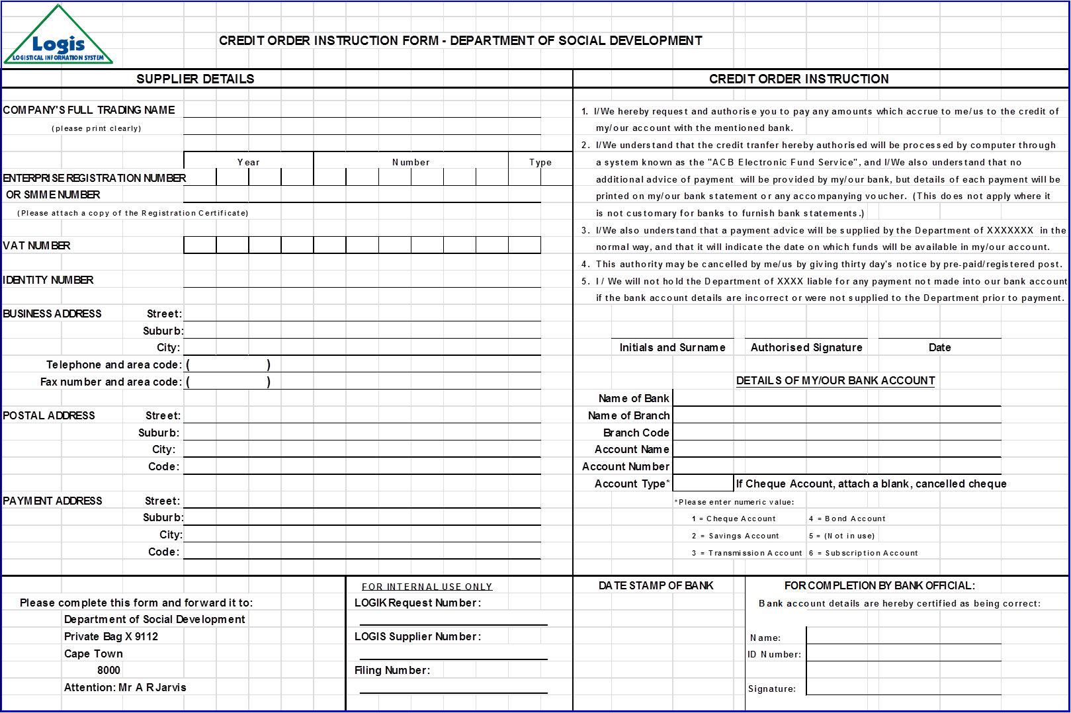

Schedule 3: Financial Matters
Please complete this schedule for the previous financial year.
Financial Year: 2012/13
NB: Income – Expenditure = Balance
Income | Expenditure | Balance

Financial Year: Current
Projected Income (indicate amount and source) | Projected Expenditure (item and cost)
Total funds

Schedule 4: Written assurance in terms of section 38 of the PFMA
Written Assurance in terms of Section 38(1) (j) of the Public Finance Management Act, 1999
In terms of Section 38(1) (j) of the Public Finance Management Act, 1999 the Department of Social Development requires written assurance that your organization implements effective, efficient and transparent financial management and internal control systems.
Part 1: should be completed by those organisations that implement effective, efficient and transparent financial management and internal control systems.
Part 2: should be completed by those organisations that do not implement effective, efficient and transparent financial management and internal control systems.
Part 1:
I, the undersigned |  | (print name)
in my capacity as |  | (position)
Of
hereby declare that |  | (organization)
Implements effective, efficient and transparent financial management and internal control systems.
Signed at |  |  |  |  |  |  |  |  |  | (place)
On this |  |  | day of |  |  | month |  |  | year
signature
Confirmed by 2 witnesses:
signature |  | print name of witness
signature |  | print name of witness

Part 2
Conditions and remedial measures to comply with Section 38(1) (j) of the Public Finance Management Act, 1999 (Act 1 of 1999 as amended by Act 29 of 1999)
In instances where written assurance cannot be obtained that effective, efficient and transparent financial management and internal control systems are implemented, the following conditions and remedial measures will apply:
- The management committee will arrange to attend and subject itself to training in business management and financial control systems.
- The management committee will implement and adhere to the financial control system prescribed by the Department.
- The management committee will subject itself to monitoring and inspection of financial records on a regular basis as conducted by officials of the Department or its representatives.
- The management committee will submit audited as well as financial expenditure reports and progress reports on training and implementation of prescribed financial systems when requested by the Department.

I, the undersigned |  | (print name)
in my capacity as |  | (position)
Of |  | (organization)
hereby declare that |  | (organization)
will adhere to the conditions as stipulated above in order to ensure effective, efficient and transparent financial management and internal control systems.
Signed at |  |  |  |  |  |  |  |  |  | (place)
on this |  |  | day of |  |  | month |  |  | year
signature
Confirmed by 2 witnesses:
signature |  | print name of witness
signature |  | print name of witness

Schedule 5: Declaration of Interest
This declaration is to be signed by all persons, management or staff involved in:
- approving or buying equipment, food, or any other items,
- signing cheques,
- accessing Internet banking,
- drawing cash for daily expenditure (petty cash),
- receiving donations, equipment, food or other items,
- handing out food or other items

The DSD wants to advise organisations that in terms of financial and auditing practices, it is advisable that persons involved or responsible for any of the above should not be from the same family.
I, the undersigned, hereby make the following declaration:
Initials & surname | Designation / post / involvement | Signature | Date

I will not use my discretion, official or non-official powers, or position within or outside the organization, to benefit myself, or any other person known to me or the organization, or any legal person, to obtain an unlawful or unauthorized advantage during the requisitioning, consideration, acceptance, or allocation of tenders, quotations or any other, or an advantage that serves to unlawfully prejudice the interest of the organization or any other person or legal person.

Schedule 6: DSD Application Process Description

STEP 1: Complete Application
This application form (including Schedules 1 to 5) must be completed and submitted together with proof of registration in terms of the Non-profit Organisations Act 71 of 1997/ Companies Act 71 of 2008/ Trust Property Control Act 57 of 1988 OR proof of application for registration in terms of the Non-profit Organisations Act 71 of 1997/Companies Act 71 of 2008/ Trust Property Control Act 57 of 1988 to the Department of Social Development’s (DSD) Head Office, within 4 (four) weeks from the date the ‘Call for proposals to partner the Department of Social Development in rendering developmental social services in the Western Cape’ is advertised.
Department of Social Development Head Office No. 14 Queen Victoria Street Cape Town 8000

STEP 2: Application Assessment
Your organisation will receive a notification ‘acknowledging receipt of application’ within 10 (ten) working days from the date the DSD receives your organisation’s application. Your organisation’s application will be assessed by the relevant programme(s) your organisation has applied for funding to. As part of the assessment process, the DSD may conduct an on-site visit to your organisation.

The programme(s) will recommend to the Head of the DSD, that your organisation be funded in accordance with the DSD guidelines for funding, should your organisation be compliant; meet the DSD’s minimum norms and standards; is strategically aligned to the DSD’s objectives and is considered in relation to other applications received to be one of the preferred organisations to deliver the service(s). Please note that the aforementioned is subject to budget availability.
The application assessment process takes approximately 4 (four) months to complete.

STEP 3: Application Approval and Transfer of Funds
The DSD will formally notify your organisation in the event that your organisation’s application is approved. Further details regarding funding allocation, outputs to be achieved as well as accountability and compliance requirements will be stipulated in the Memorandum of Agreement (‘agreement’) which will be sent to your organisation for signature.

Please note that in terms of the agreement, funds will be transferred to approved organisations in monthly transfer payments OR quarterly transfer payments commencing in the month following signature of the agreement by the last-signing party. However, notwithstanding the aforementioned, no funds will be transferred by the DSD to the approved organisation until such time as the DSD has received a signed copy of the agreement from the organisation.

STEP 4: Performance Management of Service Delivery
After payment of any funds to your organisation, the DSD requires regular feedback on the agreed services/projects as per the signed agreement. Furthermore, the DSD will call for reports in accordance with the agreement and may also visit your organisation to observe and discuss progress as well as actions recommended to improve service delivery.

