Vaccine safety surveillance
Importance of vaccine safety surveillance
Vaccines are extremely safe and effective, however, no vaccine is perfectly safe and adverse reactions may occur. Post-licensure surveillance of vaccine safety is therefore critical. Compared to clinical trials, the conditions and reasons for safety monitoring change following the licensure and introduction of a new vaccine. Vaccines are now used in the general population and recipients are no longer monitored as would be the case in clinical trials. Certain subpopulations who are commonly excluded in clinical trials, e.g. those with underlying medical conditions now get vaccinated. Large numbers of people are being vaccinated, for example, entire birth cohorts receiving infant vaccines and currently the introduction of the COVID-19 vaccine.
In addition to the vaccines themselves, the process of immunisation is a potential source of an adverse event. Therefore, other factors that can lead to AEFIs, such as incorrect administration practices, need to be monitored for safety. Uncommon and rare vaccine reactions, and reactions with delayed onset, may not be detected before vaccines are licensed. Healthcare providers should keep in mind that some commonly used vaccines have demonstrated rare and potentially serious adverse events. However, in these instances, individual and community benefits of vaccination outweigh the risks.
The main objectives of AEFI surveillance, also apply to surveillance of COVID-19 vaccines.
Objectives of AEFI surveillance
- Estimate rates of AEFI occurrence in the local population compared with trial and international data
- Identify problems, if any, with vaccine lots/brands leading to vaccine quality defect-related reactions
- Detect, correct and prevent immunisation error-related events
- Reduce the incidence of anxiety-related reactions from apprehension or pain, through education and messaging
- Prevent false blame from the public, arising from coincidental events
- Timeously monitoring to prevent morbidity and mortality in recipients of COVID-19 vaccines
- Maintain confidence by addressing concerns, and raising awareness about vaccine risks

The vaccine safety surveillance cycle, key role players and stakeholders
In South Africa we already have a vaccine safety surveillance system in place within the Expanded Programme on Immunisation (EPI). The vaccine safety surveillance cycle, as shown in Figure 7, consists of a number of key steps to monitor the safety of vaccines starting at the point where the vaccine is administered within the immunisation programme. Thereafter, the identification or detection of an AEFI, the notification and reporting of such an event and the management thereof if necessary. This is followed by the investigation of the adverse event by a multi-disciplinary healthcare team, the analysis of the data collected, causality assessment by an expert committee and finally communication on the outcome of the causality assessment of the event, including future prevention of any vaccine safety risks. The same process will apply to COVID-19 vaccination. The same process will apply to COVID-19 vaccination.

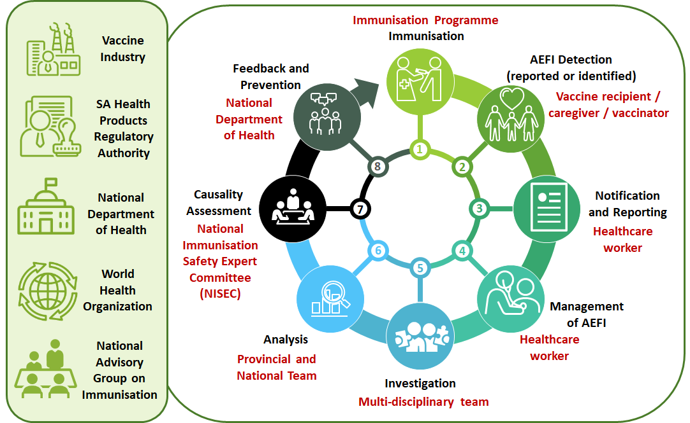
Figure 7: AEFI surveillance cycle, key players and stakeholders
Successful surveillance of AEFI is only possible through the collaborative efforts of various key players and stakeholders, as illustrated in Figure 7. Apart from the vaccinator, the vaccine recipient and other healthcare professionals, important stakeholders also include the manufacturers of vaccines, the South African Health Products Regulatory Authority (SAHPRA) responsible for the authorisation and licensure of vaccines, the National Department of Health and in particular the EPI Programme, responsible for the immunisation programme and then lastly the World Health Organisation and the National Advisory Group on Immunisation, responsible for support and guidance on immunisation in SA. Regular feedback on all AEFI is given to SAHPRA, the vaccine manufacturers, the WHO Country Office and the National Advisory Group on Immunisation.
Passive and active vaccine safety surveillance
In South Africa, vaccine safety surveillance primarily takes place through passive surveillance, known as spontaneous reporting. This happens when vaccine recipients themselves or healthcare providers detect adverse events and notify them through the system being used for collecting information on AEFIs. This kind of passive surveillance is useful for the identification of potential safety signals for adverse events that were unknown at the time of vaccine authorisation or that are unexpected. However, passive systems are unable to differentiate between a real reaction following immunisation and any coincidental event. The disadvantage of spontaneous reporting is that it does not collect data from all vaccine recipients, which means under-reporting of AEFI.
AEFI can also be detected through active surveillance, via sentinel sites or through cohort event monitoring. Active vaccine safety surveillance systems aim to collect complete and accurate information about AEFI and risk factors for AEFI in a defined population. For example, to determine if there are any differences in AEFI between male and female vaccine recipients. This is done using a continuous organised process, where each vaccine recipient is actively followed-up and all relevant data are collected from all individuals within a defined population. The advantage of active surveillance is that it minimises the under-reporting of AEFI.
With the introduction of the COVID-19 vaccine, passive and active surveillance will be implemented for the detection of AEFI (see Figure 8). In addition to the electronic vaccine data system (EVDS), currently being developed for COVID-19 vaccine recipient registration and recording of vaccination (see Section 7), an electronic system for the reporting of AEFI will be introduced in the very near future. The current paper-based system used for passive surveillance of AEFI, will be phased-out with the introduction of the Med Safety App, a mobile application for AEFI reporting by healthcare professionals as well as the general public.
In addition, for the purpose of active surveillance, the Vaccine Monitor, which has a Web and App interface, will be used for the active follow-up of vaccine recipients at different intervals, to determine if any adverse events have been experienced. Training on the electronic safety surveillance system will be provided to all healthcare workers at the implementation stage.
Figure 8 provides an overview of the Med Safety App and the Vaccine Monitor, as well as some of the advantages of electronic reporting of AEFI.
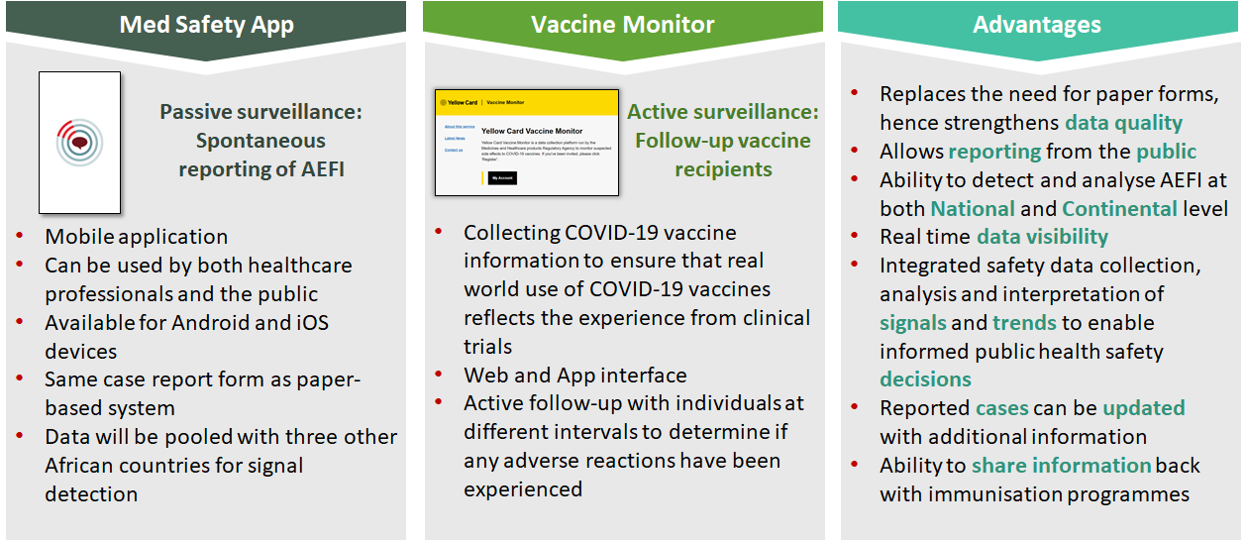
Figure 8: Electronic vaccine safety surveillance with the Med Safety App and the Vaccine Monitor
Adverse events following immunisation (AEFI) and adverse events of special interest (AESI) in the context of COVID-9 vaccine roll-out
Adverse events following immunisation (AEFI) defined in the context of COVID-19
An AEFI is defined as any untoward medical occurrence which
- follows immunisation;
- does not necessarily have a causal relationship with the usage of the vaccine;
- may be any unfavourable symptom about which a vaccine recipient complains; and
- may be an abnormal laboratory finding, sign or disease found by medical staff.
Implications for COVID-19 vaccination: The same definition will be used to identify, report, and investigate where appropriate, all AEFI with a COVID-19 vaccine. Current vaccine safety surveillance systems will be adapted to ensure the safety of the public is assured and to counter any real or perceived safety concerns.
Adverse events of special interest (AESI) in the context of COVID-19
In the context of COVID-19 vaccine introduction, normal vaccine safety surveillance systems will have to be adapted to ensure that post-vaccination safety information is collected and processed, that the safety of the public is not put at risk and to counter any real or perceived safety concerns. With the COVID-19 vaccine introduction, in addition to AEFI, any AESI will also be monitored.
An AESI is a pre-specified medically significant event
- that has the potential to be causally associated with a vaccine product;
- that needs to be carefully monitored; and
- confirmed by further special studies.
With active vaccine surveillance, the incidence of AESI for COVID-19 vaccinated and unvaccinated individuals can be compared, which will enable one to determine if there is a link between the AESI and the COVID-19 vaccine product, and if there is a need for further specific studies to confirm such an association. Conditions that are commonly considered as AESIs include serious events that have followed other immunisations, for example the following:
- Guillain-Barré syndrome (GBS)
- Acute disseminated encephalomyelitis (ADEM)
- Anaphylaxis
- Serious events potentially related to novel platforms and adjuvants
- Serious events related to vaccine failure/immunogenicity (vaccine-associated enhanced disease)
- Events that are potentially important for specific populations e.g. HIV
Such conditions are shortlisted as AESIs if there is a proven association with immunisation that is true for most, if not all, vaccines and if there is a proven association with a known vaccine platform or adjuvant that is being used in any COVID-19 vaccine. Furthermore, if there is a theoretical concern based on the immunopathogenesis of COVID-19 disease, a theoretical concern related to viral replication during COVID-19 infection, or a theoretical concern because it has been demonstrated in an animal model with one or more candidate vaccine platforms (see Figure 9).
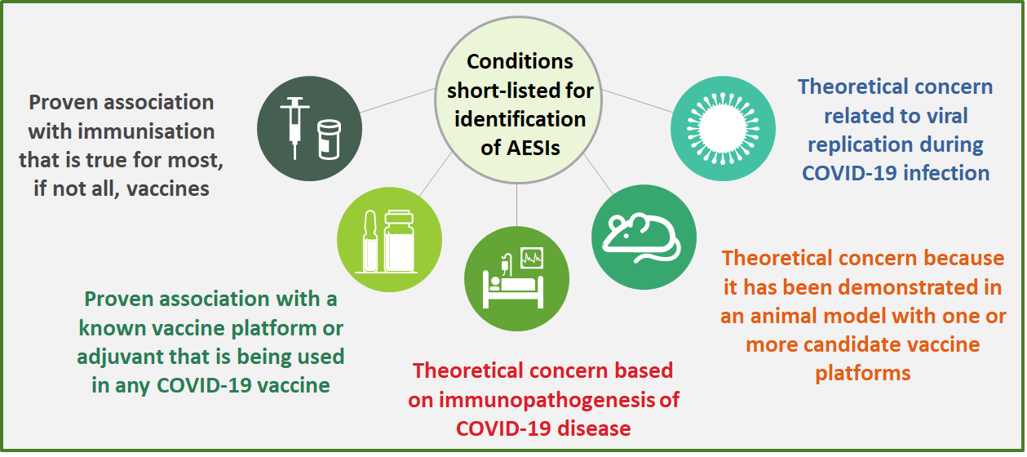
Figure 9: Conditions short-listed for active safety surveillance to identify AESIs
Differences between AEFIs and AESIs
Table 2 provides a summary of the main differences between AEFI and AESI with practical implications in the context of COVID-19.

Table 2: Differences between AEFIs and AESIs and practical implications
 | Adverse Events Following Immunization | Adverse Events of Special Inters in the context of COVID19
WHAT | Any untoward medical occurrence that follows immunization, and that does not necessarily have a causal relationship with the usage of the vaccine. The adverse event may be any unfavourable or unintended sign, abnormal laboratory finding, symptom or disease. | A pre-specified event that has the potential to be causally associated with a vaccine product that needs to be carefully monitored and confirmed by further special studies.
Purpose of collecting information | To identify all events after vaccination – determine if severe/serious, investigate (severe/serious) and do causality assessment. | To identify pre-specified specific events by a set criterion and determine if the event is associated with COVID-19 vaccination.
Identification method | Identified via spontaneous reporting by vaccine recipients or their parents, or healthcare workers or other persons who first notice the event. | Identified via an active surveillance system in sentinel sites or electronic health record by a healthcare worker or other staff in the system.
Case definition | Important | Critical
Type of reporting | All events that follow immunisation and are notified to the healthcare system. | All events identified through active surveillance that fit the case definition, irrespective of immunisation status.
Training | All frontline immunisation staff in healthcare facilities (public and private); and other relevant staff for reporting, investigation, data analysis, and causality assessment | Immunisation staff and other healthcare workers in sentinel sites and predefined active surveillance systems, EPI mangers, SAHPRA, research staff, NISEC
Users | Healthcare workers, EPI managers, SAHPRA, surveillance and information managers, epidemiologists, surveillance and information managers, vaccine safety partners including the community | Healthcare workers, EPI managers, SAHPRA, surveillance and information managers, epidemiologists, NISEC, study teams, vaccine safety partners including the community
  - Adverse events to report in the case of AEFI and AESI
Frequency and severity of AEFI
For all vaccines, AEFI are expected to occur with a certain frequency (see Table 3). There is low public tolerance of vaccine adverse reactions. Vaccines are therefore only licensed when the frequency of severe reactions is very rare and when only minor, self-limiting reactions are reported. Any increase in the frequency of AEFI should alert the vaccinator to consider other causes such as the quality of the vaccine and whether there are special risks in the population.

Table 3: Frequency and severity of AEFI
Frequency | Occurrence among vaccine recipients |  | Severity of reactions
Very common | >1/10 | >10% | Common and usually minor reactions  - Part of the immune response to vaccine  - Reactions resolve on their own  Examples: Fever, malaise, headache
Common (frequent) | >1/100 and <1/10 | >1% and <10%
Uncommon (infrequent) | >1/1000 and <1/100 | >0.1% and <1 % | Rare, usually more severe reactions  - Usually require clinical management  Examples:  - Severe allergic reaction (e.g. anaphylaxis) including an exaggerated response of the body to the vaccine antigen or component  - Vaccine specific reactions
Rare | >1/10 000 and <1/1 000 | >0.01% and <0.1%
Very rare | <1/10 000 | <0.01%

Vaccine reactions are classified in terms of intensity into minor reactions and severe reactions, which can be either serious or non-serious. Very common and common or frequent adverse events are usually minor reactions. Uncommon, rare and very rare adverse events are usually more severe reactions.
Categories of AEFI for reporting for COVID-19 vaccines
Figure 13 provides a summary of the different categories of AEFI, including a brief description of each category with reporting and investigation implications within the context of COVID-19 vaccination.
It is important to note that there is a difference between the terms "serious" and "severe" adverse events or reactions. A serious adverse event or reaction is a regulatory term, which is defined by the Uppsala Monitoring Centre as any untoward medical occurrence that at any dose results in death, requires inpatient hospitalisation or prolongation of existing hospitalisation, results in persistent or significant disability or incapacity, or is life-threatening or results in a congenital anomaly.
A severe reaction is a broader term, which includes serious reactions, but also other reactions that are severe but do not necessarily lead to long term problems. They can however be disabling, but are rarely life threatening.

Figure 13: Categories of AEFI and implications for COVID-19 vaccines
Information arising from
- One/multiple sources (including observations)
- Suggesting a new potentially causal association, or new aspect of a known association, between vaccine and event/set of related events, either adverse or beneficial
- Judged to be of sufficient likelihood to justify verification
Signal detection, verification & response is a key activity in COVID-19 context. Best done by pooling data.
Two or more AEFI cases of the same or similar events related in:
- Time/place/ geographical setting; and/or
- Vaccine (batch/lot, manufacturer, facility)
Clusters are anticipated when vaccines are administered on massive scale, as with COVID-19. Chances for immunisation errors, immunisation anxiety-related reactions and coincidental events are much higher than with routine immunisation.
Any untoward medical occurrence resulting in:
- Death
- Hospitalisation or prolongation of existing hospitalisation
- Persistent or significant disability or incapacity
- Congenital anomaly/birth defect or could be
life-threatening
Information on serious, rare and very rare adverse events following COVID-19 vaccines is lacking.
- Usually require clinical management
- Usually do not result in long-term problems
- Can be disabling but are rarely life threatening
- Can be vaccine specific reactions to the antigen or another component of the vaccine
Vaccines are only licensed when the frequency of severe reactions is very rare. Information on rare and very rare AEFI with COVID-19 vaccines is lacking currently.
- Do not pose a potential risk
- Usually occur within a few hours of vaccination
- Resolve after short period of time
- Important to inform and assure vaccine recipients of such events

Local and systemic reactions can occur as part of the immune response. Other vaccine components can trigger reactions. Reporting of all COVID-19 AEFI is compulsory.

Report within
24 hours
Investigate
within 48 hours

Report within
24 hours
Investigate
within 48 hours

Report within
24 hours
Investigate
within 48 hours

Report within
24 hours

Implications for COVID-19 vaccination: Data about rare and very rare adverse events, as well as adverse events with delayed onset, are still lacking at the time of COVID-19 vaccine registration, because no clinical trial can be powered to detect these events. Additional information will be needed for which AEFI and AESI surveillance has to be strengthened.
Vaccinators will be tasked with the responsibility of providing patient education to vaccine recipients on possible adverse events identification and immediate reporting thereof to their healthcare centre and/or healthcare providers.
For the COVISHIELD™ vaccine, reports on severe or serious AEFI must reach SAHPRA within 24 hours of occurrence through an expedited process. Reports of minor AEFI must reach SAHPRA within 7 days.
COVISHIELD™ clinical trial results showed that the majority of adverse reactions were mild to moderate in severity. Refer to Section 2.5 for the very common and common reactions reported with the COVISHIELD™ vaccine. Adverse reactions reported after the second dose were milder and less frequent, compared to the first dose. An analgesic such as paracetamol may be used to provide symptomatic relief if necessary.
Conditions for reporting of AESI with COVID-19 vaccines
As mentioned in Section 6.3 active vaccine safety surveillance will be used for the purpose of monitoring COVID-19 vaccine safety. This will be facilitated by an electronic reporting system, of which the Vaccine Monitor will be used for active surveillance of AESI. Furthermore, if the healthcare worker identifies any AESI, the vaccine recipient must be referred for clinician consultation, and the AESI case reporting form must be completed (see Section 6.7).
Master protocols are currently being developed by the WHO to facilitate the implementation of active vaccine safety surveillance for AESIs with COVID-19 vaccines. Table 4 shows a list of AESI indentified by the WHO for COVID-19 vaccines. More information about AESI is available in the WHO COVID-19 Vaccine Safety Manual (Chapter 6.5).
Table 4: AESI identified by the WHO for COVID-19 vaccine surveillance (May 2020)
AESI identified for COVID-19 vaccine surveillance
- Vaccine-associated enhanced disease  - Multisystem inflammatory syndrome in children  - Acute cardiovascular injury (microangiopathy, heart failure, stress cardiomyopathy, coronary artery disease arrhythmia, myocarditis)  - Coagulation disorder (thromboembolism, hemorrhage)  - Acute respiratory distress syndrome  - Acute kidney injury  - Generalized convulsion | - Guillain Barré Syndrome  - Acute liver injury  - Anosmia, ageusia  - Chilblain – like lesions  - Single organ cutaneous vasculitis  - Erythema multiforme  - Anaphylaxis  - Acute aseptic arthritis  - Meningoencephalitis  - Acute disseminated encephalomyelitis  - Thrombocytopenia

Causes of AEFI and implications for monitoring COVID-19 vaccine safety
A vaccine reaction is an individual’s response to the inherent properties of the vaccine, even when the vaccine has been prepared, handled and administered correctly. It must be noted that reported adverse events can either be true adverse events – i.e. resulting from the vaccine or the immunisation process – or they could be coincidental events that are not due to the vaccine or immunisation process but are temporally associated with immunisation.
Figure 11 provides a summary of the causes of AEFI, which can either be consistent or inconsistent with causal association to immunisation. Most importantly, causal association can only be determined if cases are reported and assessed.
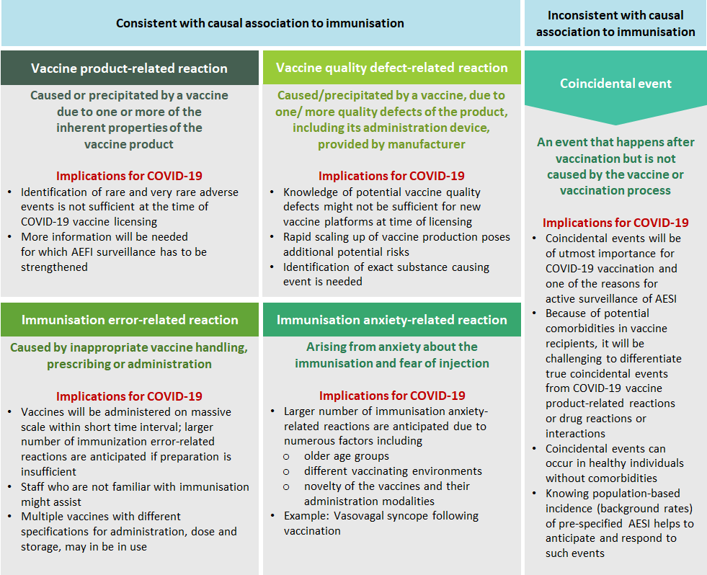
Figure 11: Causes of AEFI and implications for COVID-19
Immunisation error-related AEFI
Immunisation error-related reactions are extremely important, as they are caused by inappropriate vaccine handling, prescribing or administration, and can be prevented.
Implications for COVID-19 vaccination: Vaccines will be administered on a massive scale within a short time interval, hence larger number of immunisation error-related reactions are anticipated if preparation and training is insufficient, staff who are not familiar with immunisation might assist, and multiple vaccines with different specifications for storage, dose, administration may be in use. All these factors can introduce human error. Vaccines with a 6-hour open vial policy, such as the COVISHIELD™ vaccine, pose various risks to the immunisation programme, including immunisation errors. Hence, it is important that all vaccinators are trained on the correct handling procedures and administration techniques of COVID-19 vaccines.
Figure 12 shows various administration errors during immunisation and possible consequences thereof, especially in the case of the COVISHIELD™ vaccine.
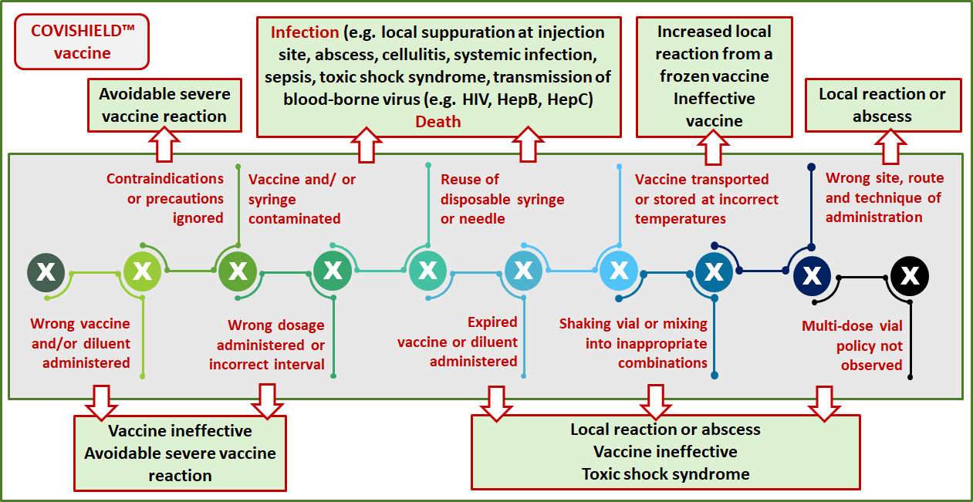
Figure 12: Administration errors during vaccination
Prevention of immunisation error-related AEFI
One of the first steps in preventing immunisation error related AEFI, is to screen the vaccine recipient for any contraindications and precautions to vaccination. Contraindications are rare characteristics in vaccine recipients that increase the risk of a serious adverse reaction if the vaccine is given, for example anaphylaxis. In the case of COVISHIELD™, a contraindication would be a known hypersensitivity to the active substance or any of the excipients listed. If any contraindication is present, do NOT vaccinate. Refer to Section 2.6 for more information on contraindications for COVISHIELD™ vaccination.
Similarly, screen for precautions, which are events or conditions that should be considered in determining if the benefits of the vaccine outweigh the risks. If so, vaccinate with CAUTION. To mitigate risks, vaccination should take place in a controlled setting, with the vaccine recipient staying in the facility at least 15 minutes after vaccination. Refer to Section 2.6 for more information on precautions for vaccination with COVISHIELD™.
Figure 13 provides a summary of the most common principles which should be adhered to in practice, to prevent any immunisation error related AEFI.

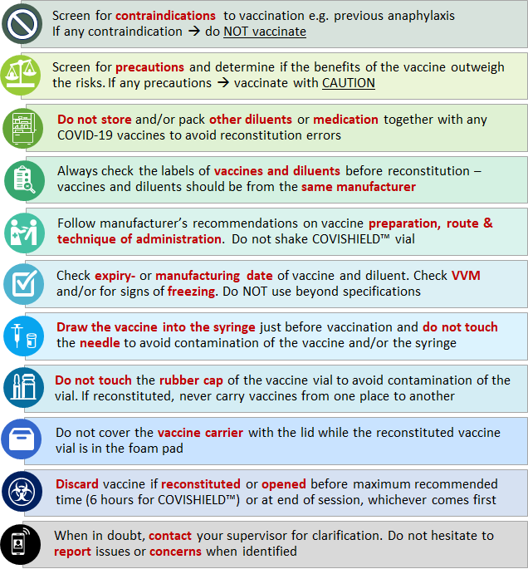
Figure 13: Prevention of immunisation error related AEFI
Anaphylaxis risks and mitigation
Anaphylaxis is a severe and potentially fatal reaction, however very rare (estimated as <1/1 000 000). Proper diagnosis and urgent treatment and management are therefore essential. When sudden loss of consciousness occurs 5 to 30 minutes after immunisation, consider anaphylaxis as a possible diagnosis, in addition to fainting (vasovagal syncope). The risk of anaphylaxis is determined through a series of questions posed in the written informed consent. All health facilities where vaccination is offered, must be equipped with an emergency tray, and vaccinators must be trained in the management of anaphylaxis.
A vaccination reaction may often also occur from immunisation anxiety arising from being anxious about the immunisation process or fear of injections. Vaccinators should provide adequate information to the vaccine recipient on the pros, cons and procedure for COVID-19 immunisation. Vasovagal reactions with or without hyperventilation are commonly seen after vaccination. It is therefore important for vaccinators to know the difference between an acute stress response (anxiety-related reactions) and anaphylaxis, including the management of these reactions. Anxiety-related reactions can be rather dramatic and are often mistaken for anaphylactic reactions. Correct diagnosis is also important to ensure that it possible to vaccinate those who might be at risk of serious infections, should they not be vaccinated. Refer to Section 5.4 for information on the management of anaphylaxis.
Reporting and investigation process for AEFI and AESI
Goal of reporting and investigation of AEFI and AESI
The ultimate goal of timely reporting and investigation of all AEFI and AESI is illustrated in Figure 14. When this is done, timely causality assessment of reported cases can take place within 30 days as stipulated by SAHPRA. If any programme errors are identified, for example errors with administration, immediate remedial action can be taken. Preventing any safety risks and safety communication, will assure the public of the integrity of the immunisation services, and create confidence in vaccination, which is what we want with COVID-19 vaccination.
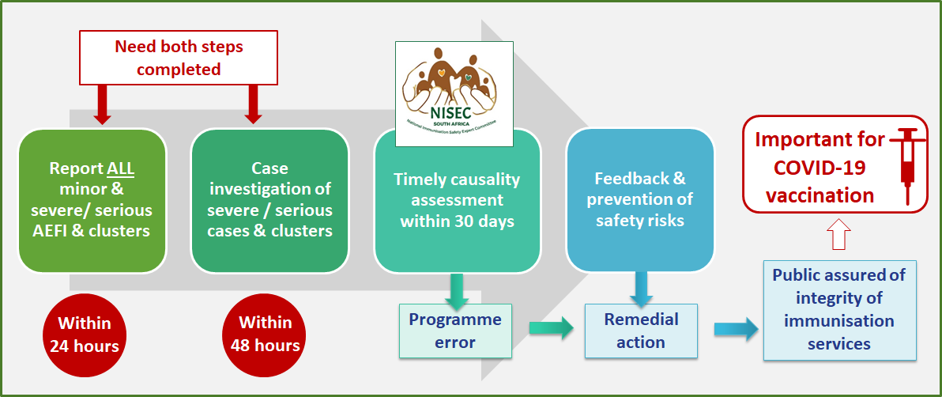
Figure 14: Goal of reporting and investigation of AEFI
Responsibility to report an AEFI and an AESI
Reporting of AEFI and AESI is the responsibility of all healthcare workers providing immunisation services, health workers providing clinical treatment of AEFI and AESI in health centres, hospitals, etc., vaccine recipients and researchers conducting clinical trials or field trails. Furthermore, healthcare workers have a professional responsibility to report any adverse events.
For the COVISHIELD™ vaccine, reports on severe or serious AEFI must reach SAHPRA within 24 hours of occurrence through an expedited process. Reports of minor AEFI must reach SAHPRA within 7 days. All case reporting forms submitted to the EPI Programme at the NDoH, will be submitted to SAHPRA by the National AEFI Coordinator, within the stipulated time. Updated reports will be submitted as cases are being investigated and causality assessment completed.
Case investigations
All AEFI detected at any level of care should be reviewed for seriousness and severity. If the AEFI is considered to be minor and NOT severe or serious, a detailed case investigation and causality assessment will not be required. This should be noted on the CRF (Annexure 10), however, appropriate clinical management and intervention should be provided to the vaccine recipient.
All serious and severe AEFI cases, clusters and AESI must be investigated by a multi-disciplinary team consisting of various healthcare professionals within 48 hours. Pay special attention to the following events, which must be investigated and reported accordingly:
- All deaths thought to be related to immunisation
- All cases of hospitalisations thought to be related to immunisation
- Life threatening event thought to be related to immunisation
- Significant disability thought to be related to immunisation
- Encephalopathy within 7 days of immunisation
- Collapse or shock-like state within 48 hours of immunisation
- Fever of ≥38°C within 48 hours of immunisation
- Seizure within 3 days of immunisation
- Severe local reactions following immunisation
- Injection site abscesses following immunisation
- Congenital anomaly
- Birth defect or a medically important event or reaction
- Events with an unexpected high rate or severity, or a suspected signal
The completed CRF and CIF with all clinical records will be submitted to the provincial office via the EPI/CDC District Surveillance Officer. At the provincial level a line list (Annexure 12) will be compiled, which will be submitted to the National AEFI Coordinator.
The case investigation team is a multi-disciplinary team coordinated by the District EPI or CDC Surveillance officer. They will conduct a facility visit and use available clinical records, vaccine recipient interviews, vaccinator interviews and observations to complete the case investigation form (CIF) (Annexure 11). Key people who should be part of the investigation include the following people:
- EPI co-coordinator / manager
- Vaccine logistics / cold chain co-coordinator
- District pharmacist (if co-coordinator not pharmacist)
- Referral hospital paediatrician / clinician
- Communication’s officer; media and community liaison
- Community nurse
- Epidemiologist
- Clinical psychologist and district surgeon (in case of death)
Depending on the type of case, for example in the case of a death, a psychologist and district surgeon could be included. It is important to note that the vaccinator is excluded from the case investigation team, but not excluded from investigation process.
Causality assessment
Causality assessment for all investigated cases is done by the National Immunisation Safety Expert Committee (NISEC). This is a non-statutory, standing, ministerial-appointed, advisory committee of independent experts. They use a structured and systematic causality assessment process to classify cases in terms of causality and determine the contribution of immunisations and the immunisation programme to such cases. They provide independent, scientific advice and recommendations to the NDoH on immunisation safety and AEFI. The worksheet used by NISEC for causality assessment and classification of cases is available in Annexure 9.
Prerequisites for AEFI causality assessment
- Case investigation completed
Both the CRF and CIF completed, with case investigation completed.
- Specific diagnosis
There must be a specific “diagnosis” (clinical sign, abnormal laboratory finding, symptom and/or disease) which is being investigated for and association with immunisation.
- Details and evidence
All details of the case should be available at the time of assessment, including supporting documentation (clinical notes, laboratory results, autopsy report, etc.).
Feedback on the outcome of causality assessment will be provided to the healthcare facilities who submitted a particular report/s. Complete information is absolutely essential to enable causality assessment, and even more so for all COVID-19 vaccine related AEFI and AESI.
Data collection tools for AEFI and AESI surveillance
The existing tools, used for the reporting, investigation, management and processing of AEFI data, have been adapted for COVID-19 vaccination, as recommended by the WHO. These tools are available in Annexures 10 to 13 and can be downloaded in electronic format from the Knowledge Hub, from the NICD website and from the SAHPRA website. The case reporting form for AEFI will soon be available on the Med Safety App.
All reporting documentation must be submitted to the following address:
AEFI@health.gov.za
Figure 15 provides and overview of the different tools used for data collection on all AEFI and AESI.
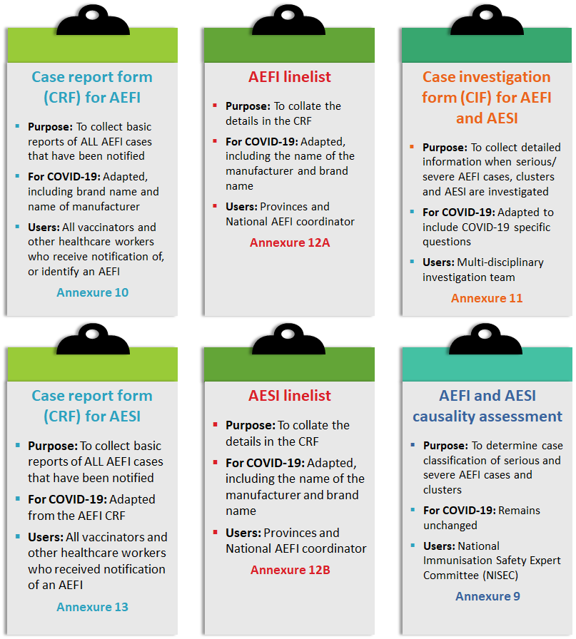
Figure 15: Tools for COVID-19 vaccine-related AEFI and AESI reporting, investigation and causality assessment
Summary process for AEFI and AESI reporting and case investigation
Healthcare workers should follow the process illustrated in Figure 16 for the detection, reporting, investigation and feedback on all AEFI and AESI, including the timeline requirements and documentation to complete.

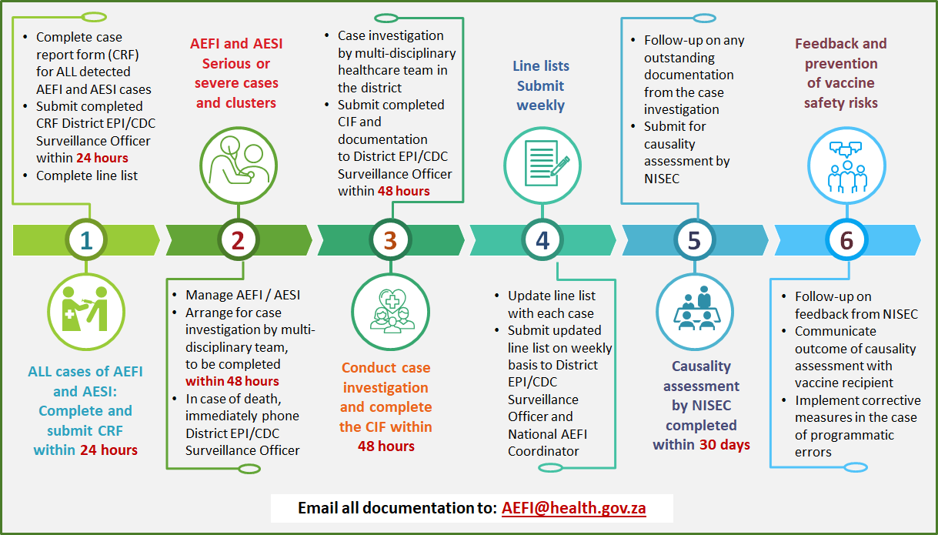

Figure 16: Key steps in the reporting process for all AEFI and AESI

