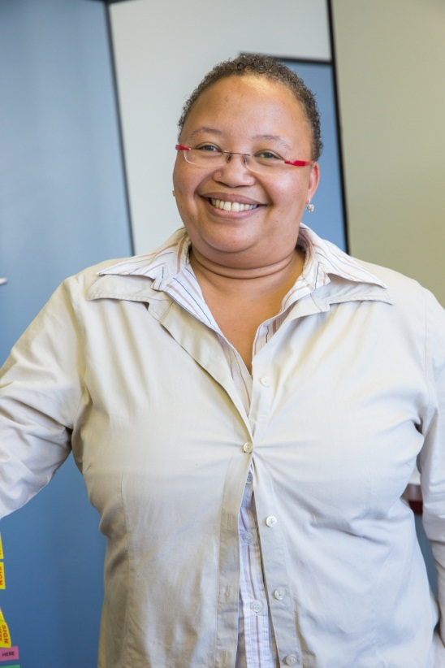
I am a diabetic. I am a diabetic. I’ve said it so many times like a mantra, hoping that it will sink in. Five years after being diagnosed in my thirties, I still find it hard to believe. And this is why I’ve decided to tell my story.

I was on a road trip during the month of December with a family member when I started sweating profusely. I was walking around with a towel around my neck to keep the perspiration at bay, and falling asleep every time I sat down. I was thirsty and hungry all the time, so much so that my stomach lining would burn from hunger, yet no one thought to check for diabetes, even though I had family members who were also diagnosed with the disease. I couldn’t even
begin to describe to people how tired I was all the time, and I and those that knew me just couldn’t understand why I felt sick all the time.

On my road trip I stopped over in De Aar, a small town in the Northern Cape, to visit my cousin and his family. His wife and him had both been diagnosed with diabetes and were using Medformin (oral medication). Two hours after having arrived there, I fell asleep during a lively family discussion and when I woke up, I was staring into very worried faces. My cousin’s wife, Cathy, who was a professional nurse, told me to go see my doctor because she suspected I had diabetes.
I enjoyed the rest of my holiday and returned to Cape Town and back to work, without seeing a doctor and subsequently fainted in January. I finally went to the doctor where my blood sugar levels were tested and found to be 34. A healthy person’s blood sugar levels vary between 4,4 – 6,6. More blood tests were done to see what my average blood glucose levels were over a period of three to six months. This was the final nail in the coffin for me, as it confirmed that the levels were completely out of control.

I was started off with oral medication e.g. Glucophage, Glucophage XR and Diamicron etc . but these didn’t bring my blood glucose levels down and made me extremely ill. After less than two months I was on a combination of insulin and oral medication. The doctor in consultation with a specialist had removed the oral medication and had put me on insulin only, by the end of the third month. I was now taking short acting insulin before every meal (3 times a day) and long acting insulin (x1) before I went to bed at night.

Several years later I am now injecting myself 5 times a day, with three different types of insulin. I am pricking my fingers between 3-5 times a day. Recording my readings every day and phoning and emailing my diabetes care team, that help me monitor my levels. Subsequently with the diabetes I had also later been diagnosed with cholesterol, gout, fibromyalgia, rheumatoid arthritis and had asthma from childhood. Most of it, I have been told is hereditary, as my doctor says: “an unlucky role of the dice.” All of these chronic diseases also have an impact on how well I control the diabetes.

My diet has been changed to cut out sugars and minimize harmful foods that could push up my sugar levels. The first six months was absolute torture, because it felt that everything that I put in my mouth was bad for me, and would increase the glucose levels. It was a balancing act, not just with my weight, which had to be reduced drastically, but it was also about what I ate and the amount of insulin I used. Everyday continues to be a struggle to maintain, if not decrease my weight. Most people will never understand how difficult it is for a diabetic, especially on insulin, to lose weight. I have gone from a size 26 to a 16 in dress size in the last few years, yet it still isn’t healthy.

I’m telling my story so that every single person who reads this will go and get their blood glucose levels tested. Not just once, but regularly. That you will also get all your loved ones tested regularly as well. This is a silent killer that has so many health complications like heart disease, stroke, blindness, amputations and kidney failure. In most cases these complications could have been avoided entirely by early diagnosis and proper treatment.

I want to scare you, no, I need to scare you, because not enough people realize that about 6% of our population suffers from diabetes, and that’s just the ones that have been diagnosed. It takes an average of seven years for a person to get diagnosed with diabetes for the first time and the sad fact according to the Centre for Diabetes and Endocrinology is that 30% of people with type 2 diabetes have already developed complications by the time they are diagnosed.
Since I have been diagnosed, several of my closest friends have been diagnosed with the disease and some of them have lost their lives. I am finally writing this article in the hope that I can save your life.
I am Emerantia Cupido and I am a diabetic.

