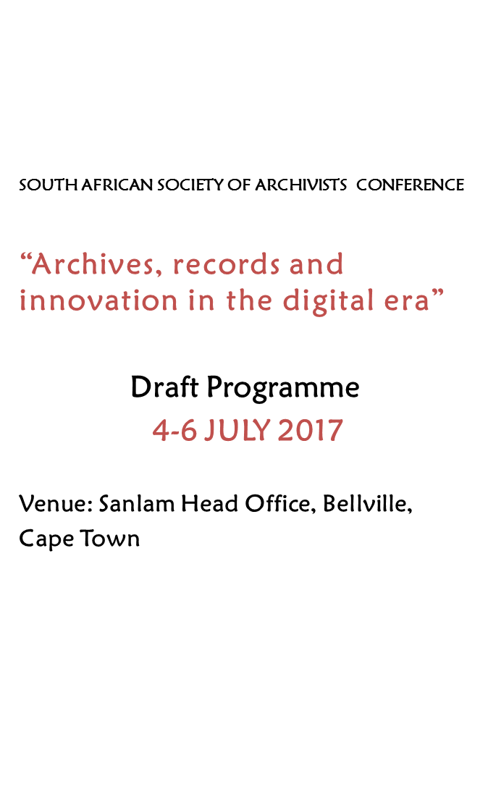

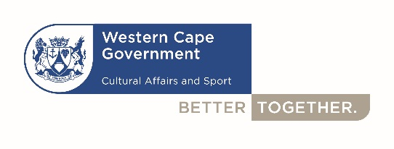 cid:image007.png@01D2EFFF.60CE7DD0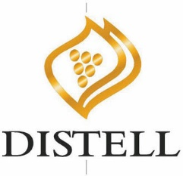

|  |  |
| --- | --- |
| **Tuesday, 4 July 2017 Workshop: Archival Diplomatics and Digital Records Forensics** | |
|  | **Facilitator: Dr Corinne Rogers, University of British Columbia** |
| This workshop will present the theory and application of archival diplomatics to assess records systems and evaluate records management programs. Topics covered will include authenticity, reliability, and accuracy of records, the role of records in accountability and as evidence, integration of paper and electronic records systems, and an introduction to digital forensics processes in support of records management and archival work. The workshop will consist of lecture, discussion, and group work. | |
| **Dr Corinne Rogers’ biography** | |
| *Corinne Rogers (PhD, UBC) is the Project Coordinator for the international research project, InterPARES Trust, and an adjunct professor at the School of Library, Information, and Archival Studies at the University of British Columbia, where she teaches Archival Diplomatics, and Digital Diplomatics and Digital Records Forensics. Her research interests include authenticity of digital records, documents and data, information ethics, and the application of digital forensics in archival practice.* | |
|  | |

|  |  |
| --- | --- |
| **Wednesday, 5 July 2017** | |
| 07:30 | **Registration and Tea** |
|  | **Chairperson: Nikiwe Momoti** |
| 08:00 | **Opening and Welcome: *Mr Brent Walters Head of Department: Western Cape Department of Cultural Affairs and Sport***  **Message of support: Paul Mullon, SASA Chairperson**  **Message of support: SANLAM**  **Message of support*: Ms Petro Coreejes-Brink, Chairperson Western Cape Archives Advisory Committee***  **Welcome Address: Minister Anroux Marais: Western Cape Department of Cultural Affairs and Sport** |
| 09:00-  09:40 | ***Dr Corinne Rogers, University of British Columbia***  **Keynote address: Information ethics and the application of digital forensics in archival practice** |
| 09:40-  10:00 | ***Goolam Mohamed, Neill Payne & Mark Meyer, Western Cape Department of Cultural Affairs and Sport***  **Implementation of enterprise content management in the Western Cape Government** |
| 10:00-  10:20 | ***Prof Trywell Kalusopa, Tshepo Mosweu, Shadreck Bayane, InterPARES Project***  **Implementation of enterprise-wide systems to manage trustworthy digital records in Botswana’s public sector** |
| 10:20-  10:40 | ***Ndakasharwa Muchaonyerwa, University of Fort Hare***  **Accessibility and security of digital records in the Office of the Premier in the Eastern Cape Province** |
| 10:40-  11:00 | **Questions and Discussions** |
| 11:00-  11:20 | **Tea** |
|  | **Chairperson: Paul Mullon** |
| 11:20-  11:40 | ***Dr Irene Moseti, InterPARES Project***  Management of trustworthy digital records in Kenya |
| 11:40-  12:00 | ***Tshepho Mosweu & Olefhile Mosweu, University of South Africa***  The management of electronic court records systems: a review of literature in selected African countries |
| 12:00-  12:20 | ***Keneilwe Porogo & Prof Trywell Kalusopa***  Digital preservation readiness in the context of e-government in the public sector in Botswana |
| 12:20-  12:40 | ***Forget Chaterera, Mehluli Masuku & Sindiso Bhebhe, InterPARES Project***  Integrating ERP systems into records management systems in Zimbabwe |
| 12:40-  13:00 | **Questions and Discussions** |
| 13:00-14:00 | **Lunch** |
|  | **Chairperson: Nomaza Dingayo** |
| 14:00-  14:20 | **Motivational Session** |
| 14:20-  14:40 | ***Antenie Carstens, National Library of South Africa (Cape Town Campus)***  Selecting appropriate digitizing equipment for digitization projects of South African Heritage Collections |
| 14:40  15:00 | ***Paul Mullon, Mpho Ngoepe, Jonathan Mukwevho & Mangi Mulaudzi, InterPARES Trust Project***  A framework for trust in digital records to support the auditing process in South Africa |
| 15:00-  15:20 | ***Letitia Myburgh, Standard Bank Heritage Centre***  **The 150th year watershed – the creation of Standard Bank Heritage Centre’ secure digital repository** |
| 15:20-  15:40 | ***Molebelli Batlhole, University of Botswana***  **Conversation for a comprehensive repository policy framework at the University of Botswana** |
| 15:40-  16:00 | ***Leila Bloch, Jewish Museum***  **Collaboration and Contestation in a Communal Archive** |
| 16:00-16:20 | **Questions and Discussions** |

|  |  |
| --- | --- |
| **Thursday, 6 July 2017** | |
| **08:00 – 08:30** | **Coffee/ Tea** |
|  | **Chairperson: Nkitseng Mahalefa** |
| **08:30 – 08:50** | ***Prof Carolyn Hamilton & Grant McNulty, University of Cape Town***  The five hundred year archive: building a digital archive for the southern African past before colonialism |
| **08:50 – 09:10** | ***Chris Grove, National Archives and Records Service of South Africa***  One small step for Tinfoil . . . but a whole giant adventure for South African audio-visual archivist: a 23 odyssey |
| **09:10 – 09:30** | ***Dr Shadrack Katuu, InterPARES Project***  Curriculum design for records created in networked environments at institutions of higher learning in Africa |
| **09:30 – 09:50** | ***Ashabai Chinyemba, University of Witwatersrand***  Managing transition from a paper-based to a digital environment for the management of records at the University of Witwatersrand |
| **09:50 – 10:10** | ***Nikiwe Momoti, Western Cape Archives and Records Service***  **A framework for records management implementation in support of an intelligent university*.*** |
| **10:10 – 10:30** | ***Thandolwenkosi Nyathi, Peterson Dewah, Ammi-amitai Ndlovu & Prosper Dube, National University of Science and Technology***  **Re-engineering archives through the Document Management System at the National University of Science and Technology in Zimbabwe** |
| **10:30 – 10:50** | ***Sidney Netshakhuma, University of Mpumalanga***  **Role of records management on the incorporation of Kangwane into Mpumalanga Province** |
| **10:50 – 11:10** | **Questions and Discussions** |
| **11:10 – 11:30** | **Coffee/ Tea** |
|  | **Chairperson: Jabu Nkatingi** |
| **11:30 – 11:50** | ***Mpho Ngoepe, University of South Africa***  Behind every clean audit, there is records management: the role of records management into the audit process in South Africa |
| **11:50 – 12:10** | **Tshoganetso Makhumalo & Peterson Dewah**  Issues surrounding implementation of a records management programme: the case of Land Boards in Botswana |
| **12:10 – 12:30** | ***Keneilwe Margret Porogo & Nna Yves Caesar Motlhasedi, University of Botswana***  The Power of Big Data Analytics and Records Management Running Insurance Business in Botswana: A comparative Study of Botswana Insurance Life Limited and Hollard Insurance |
| **12:30 – 12:50** | ***Juliet Erima, Elijah Nyaberi & Naphtali Chweya***  Assessing progress towards implementation of access to information legislation |
| **12:50 – 13:30** | **Questions and discussions** |
| **13:30 – 14:30** | **Lunch** |
| **14:30 – 16:00** | **SASA Business** |
| **17:00 – 22:00** | **Cocktail** |