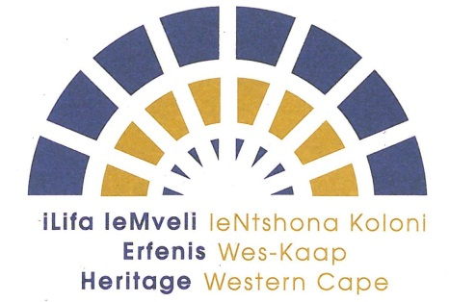 | ISICELO SOKUSEBENZA KWIKOMITI YELIFA LEMVELI LENTSHONA KOLONI (HWC)
Nceda ugcwalise i-fomu ngokufaka impendulo kwezi bhokisi zingezantsi, uze uyingenise phambi kolwesiHlanu umhla we 18 kweyeDwarha 2019.

Amaxwebhu afunekayo:
- Inkcukacha zakho ngokupheleleyo (i-Curriculum Vitae)
- Ikopi eqinisekisiweyo yesazisi sakho
- Ifomu yokudandalazisa uchaphazeleko
- Iikpi eziqinisekisiweyo zenkcukacha zemfundo

Igama: | Idilesi yalapho uhlala khona:
Inombolo yesazisi:
Umsebenzi wakho: | i-imeyile:
Iminyaka yamava: | Inombolo kamakhalekhikhini:
Iinkcukacha zemfundo: | Umnxeba :
Ukubhaliswa kweenkcukacha zemfundo yomsebenzi wakho | Ifekisi:

Ndinomdal wokusebenza kwezi Komiti zilandelayo: (nceda uphawule ibhokisi oyikhethayo okanye ozikhethayo)
IKomiti ye-Archaeology, Palaeontology and Meteorites (APM)

IKomito ye-Build Environment and Landscapes (BELCOM)

IKomiti yeMpembelelo yoVavanyo (IACOM)

IKomiti yoLuhlu, ukuHlela noToliko (IGIC)

IKomiti yeziBheno

Ndake / andizange ndake ndasebenza kwiKomiti yeLifa leMveli leNtsona Koloni okanye kwiBhunga layo ngaphambili.

Ukuba wawuke wasebenza ngaphambili nceda uchaze iKomiti okanye iiKomiti owawusebenza kuzo uze uchaze iminyaka yesiqingatha wawuyisebenze kulo-ofisi

1.

2.

3.

4.

5.

6.

7.

Izizathu zomdla wokusebenza kwiiKomiti :
1.

2.

3.

4.

5.

Nceda ubuyise ifomu egcwalisiweyo kunye nekopi yeenkcukacha zakho i-cv isazisi sakho kunye neenkcukacha zakho zemfundo njengoko intengiso imema izicelo.

Ndiyadandalazisa ukuba olu lwazi ndilunikeze apha (kuquka nendiziqhobosheleyo) ndilugcwalise ngokupheleleyo nongokulungileyo ngokobungakanani bolwazi lwam. Ndiyaqonda ukuba ulwazi olufumaneka libubuxoki lingabangela ukuba isicelo sam sichithwe singaqalwaselwa ukuba ndiqeshiwe.

ISANDLA SOMCELI : _________________________ UMHLA: __________________

