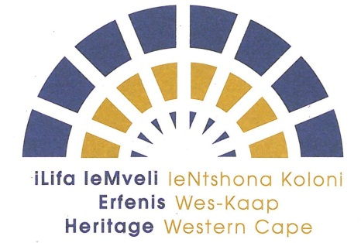 | APPLICATION TO SERVE ON A COMMITTEE FOR HERITAGE WESTERN CAPE (HWC)
Please complete the form by filling in your response in the below boxes and submit by no later than Friday 18 October 2019.

Required documentation:
- Curriculum Vitae
- Certified copy of your ID
- Declaration of interest form
- Certified copies of qualifications

Name: | Physical Address:
Identity Number:
Profession: | E-mail:
Years of experience: | Cell:
Qualifications: | Tel:
Professional registration/s | Fax:

I am interested in serving on the following committee/s: (please tick relevant box/s)
Archaeology, Palaeontology and Meteorites Committee (APM)

Build Environment and Landscapes Committee (BELCOM)

Impact Assessment Committee (IACOM)

Inventories, Gradings and Interpretations Committee (IGIC)

Appeals Committee

I have / I have not previously served on a HWC committee or its Council.

If you have previously served kindly indicate the committee/s on which you served and the years of each term of office:

1.

2.

3.

4.

5.

6.

7.

Reasons for interest in serving on the committee/s:
1.

2.

3.

4.

5.

Please return the completed form together with a copy of your CV; ID and qualifications as per the advertisement calling for applications.

I declare that all the information provided (including any attachments) are complete and correct
to the best of my knowledge. I understand that any false information supplied could lead to my
application being disqualified or my discharge if I am appointed.

SIGNATURE OF APPLICANT: _________________________ DATE: __________________

